IMAGINE GROVE
Scott Grove
scott@scottgrove.com https://www.imaginegrove.com/
585-738-2288

Instructions for connecting to a group meeting with Zoom (video conference app)
Prior to your meeting time, you will receive a unique link from me or your moderator. Click on it or copy it into your browser. A browser window will open, and Zoom will initiate a download of the software that you need. Follow the prompts to install the software. This is done only the first time you join a Zoom meeting on a computer or device.
You do not need to sign up for an account with Zoom, nor do you need to enter a "free trial" of a paid account. It is FREE to join my meeting through Zoom.
You can click on “Open Zoom” or “download & run Zoom.” If you click on “click here” (at the bottom of the screen) you will be prompted to “Open Zoom.” If you can’t download the software, click on “join from your browser.”
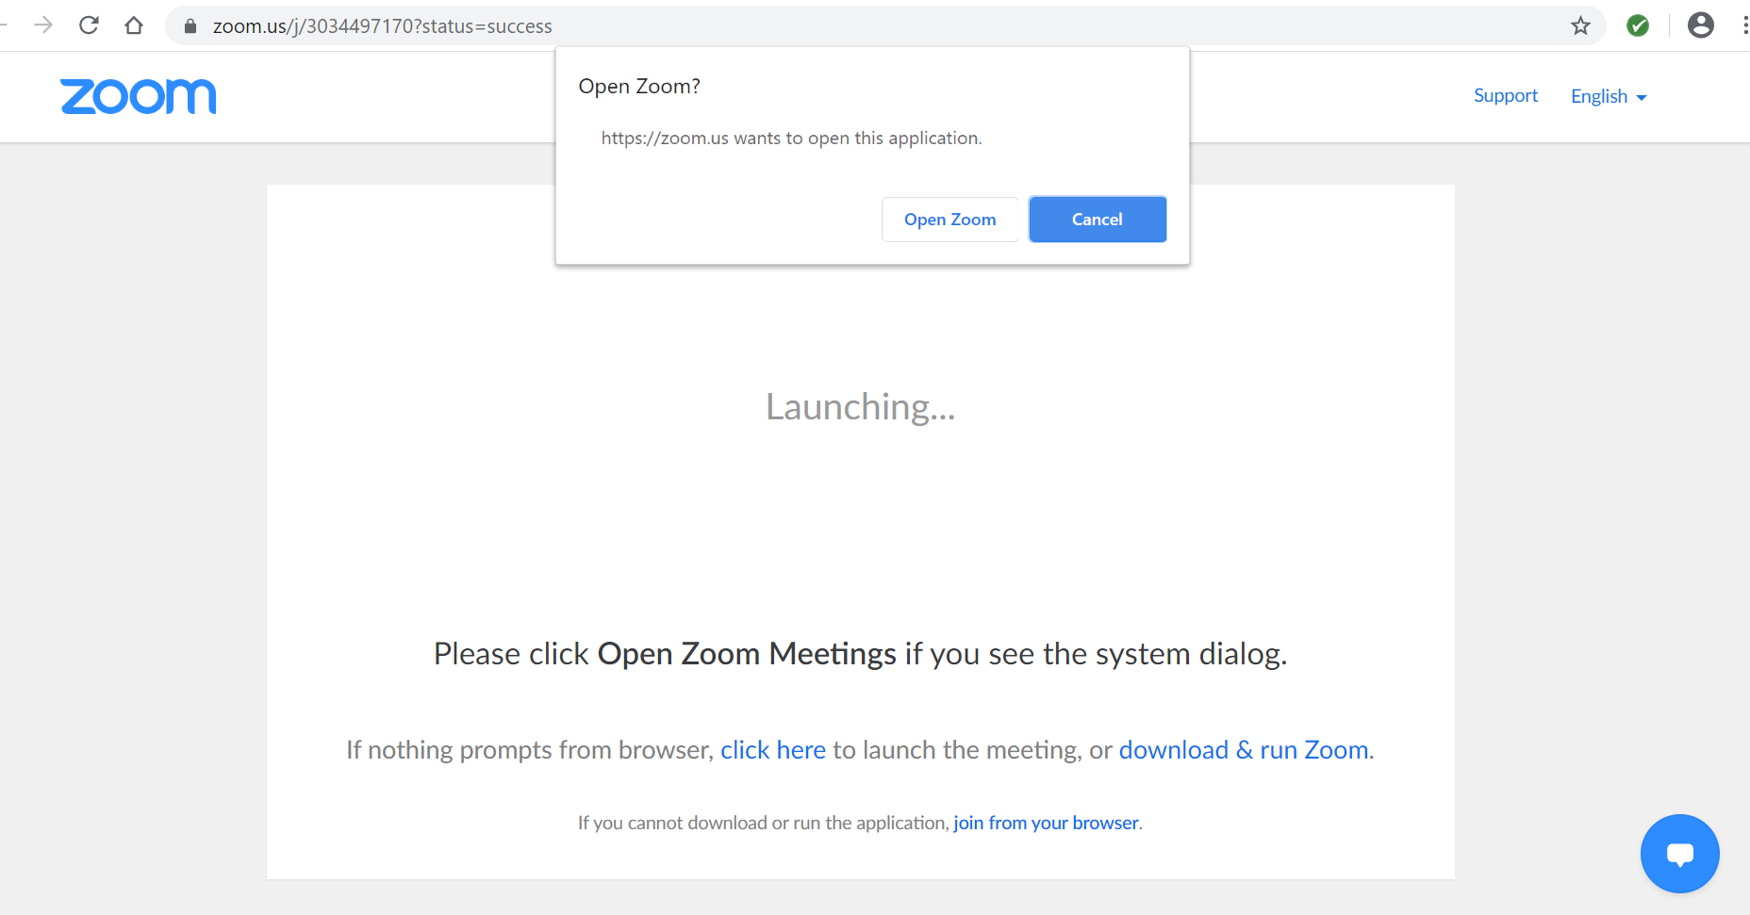
Open zoom

Zoom offers a video tutorial here: https://support.zoom.us/hc/en-us/articles/201362193-How-Do-I-Join-A-Meeting-Setting

Once you are on Zoom, you’ll see the image below. You will receive an invitation which a waiting room to join the meeting, I will start the live feed video at the scheduled time and we’ll be connected by a live video.
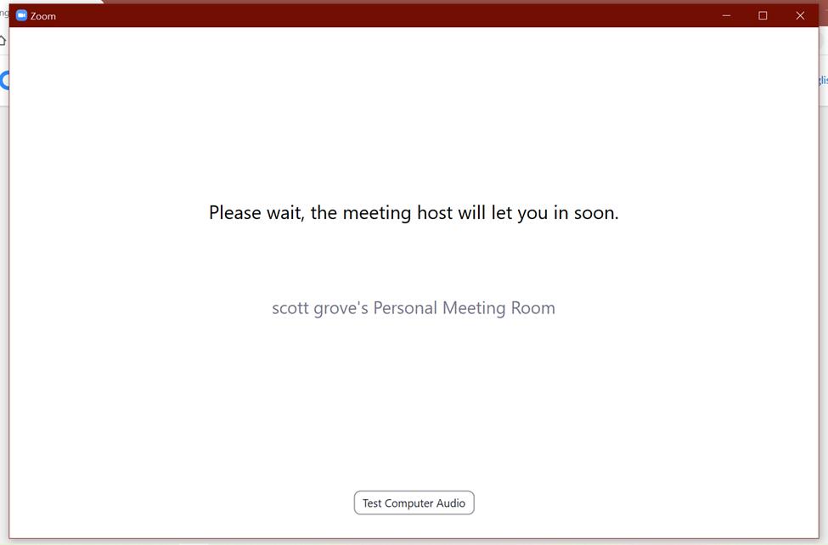
Setting yourself up in the meeting: You can connect with video and audio so that you can hear the demo, and others can see and hear you. Fill in your first and last name. If you want to join with video (facing yourself), click on the “Join with Video” button.
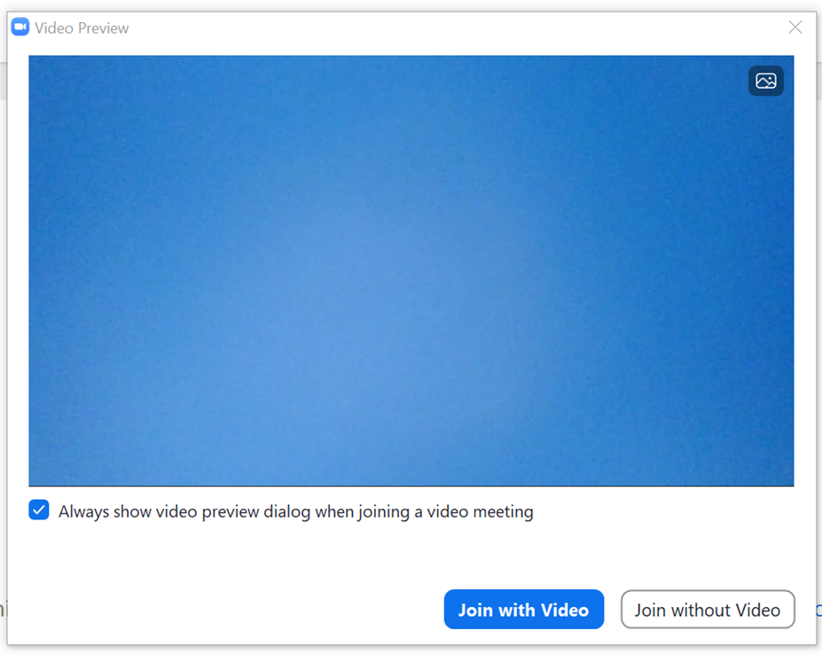
Note: You do not need a camera or microphone to join the meeting and see the demonstration, but you need speakers on your computer or a headset to hear it. If you chose the “Join without Video” option, the others will not be able to see or hear you.
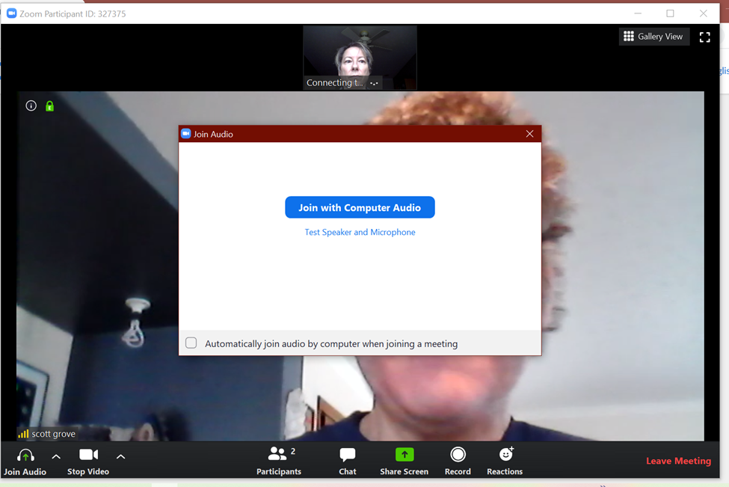
Click the “join with computer audio” button. If your device does not have a microphone and speaker, you can use your phone as a microphone and speaker.

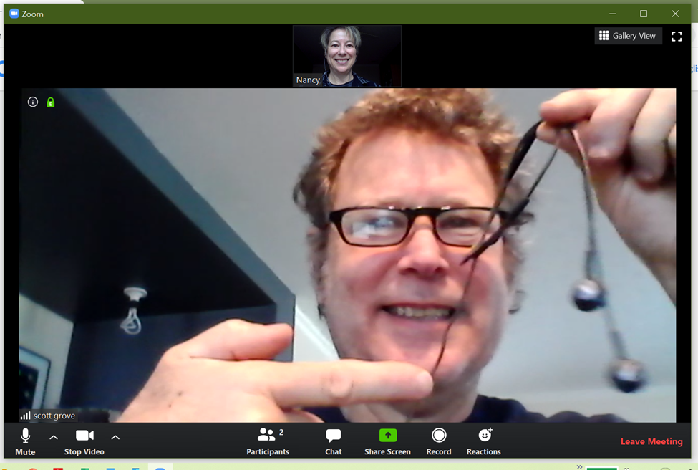
Mute, video
Go to the bottom row of the Zoom window, and you will see a row of icons. The far left is a microphone icon. This is where you toggle (mute or un-mute) your own microphone. The icon to the right of that is a camera icon. This lets attendees see a thumbnail of you on live video (like my wife Nancy’s image above). Click these icons to turn on or off your audio or video. It’s best to mute your audio unless you have a question, otherwise everyone will hear what goes on in your background (dog barking, kids playing, etc.).
Note: The row of icons at the bottom of the screen is hidden if there is no mouse activity. Move your mouse to get the icons back when you want them.
Using the Chat feature: There is an icon labeled Chat at the bottom of the Zoom window. When you click on it, a sidebar opens on the right with a Chat Window. If you are in full screen mode, Chat opens in a separate window. In the “To:” field at the bottom, you can choose whom you want to message - either everyone, someone privately, or to Scott privately. Type your message where it says “Type message here,” and press Enter to send it.

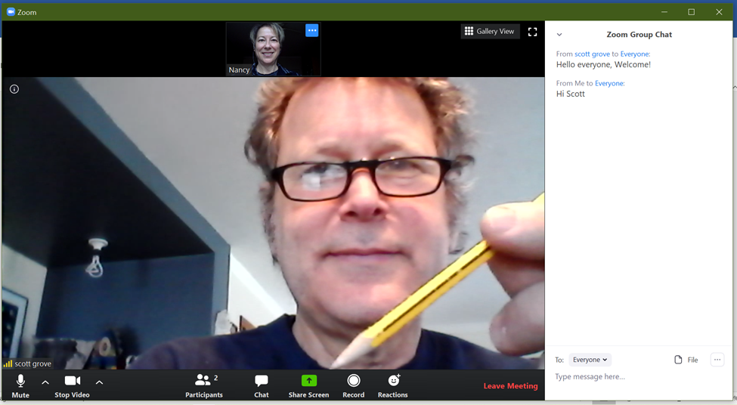
mute
Chat
Choose whom to message

Asking questions during the meeting: You can ask questions during the demo or wait until the end. To ask a question, un-mute your microphone and speak. If you don't get my attention that way, use the Chat feature to get the Moderator's attention, and he/she will let me know.

NOTE –When asking questions, please note that it’s better if you type them as we go along. If I have a moderator, they can feed me questions to my earpiece. If not, I can take a moment to read through questions and answer them during a short break. If you ask a question verbally, note that there may be a video feed delay. Please be patient and talk clearly and slowly so everyone can hear. I will make sure that there will be plenty of time to answer everyone’s questions.

Leaving the meeting: You can leave any time, and you can come back by clicking the link again and joining the meeting. To leave the meeting, click "Leave Meeting" at the lower right of the Zoom window.

Speaker view: Film strip of other participants
Full screen view

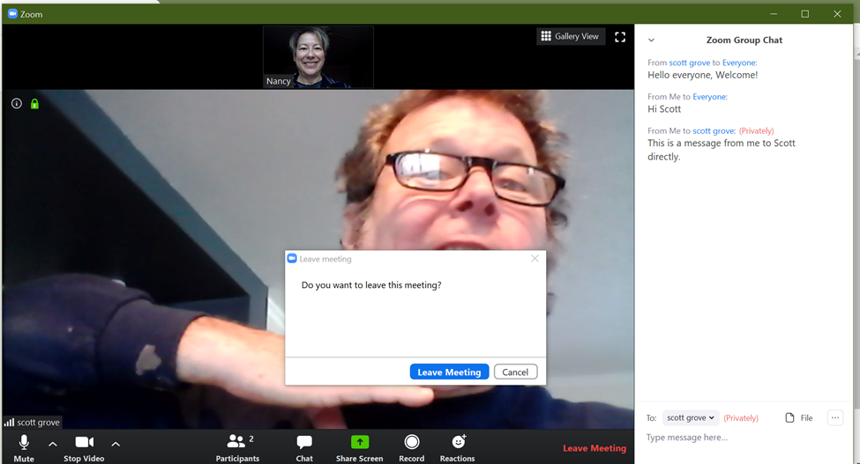
Leave meeting
… icon name change

Name
Gallery view
Participants

Additional controls: You can change your name later if you didn’t do it when you first joined. Right click on the “…” icon on your thumbnail video, or click “More” in the Participant window, and select Rename.

Click the Participants icon at the bottom of the screen to see who has joined the meeting.

Speaker view, Gallery view: When you join the meeting, it opens in Speaker View, and you see a large video and a film strip of thumbnails (the other participants’ videos). Before the meeting starts, the person who is speaking is shown in the large video. Once the meeting starts, the host or co-host will spotlight the demonstrator’s video so that is what everyone sees no matter who is talking. In Speaker View, the words “Gallery View” (or a grid icon) are in the upper right corner of the Zoom window. Click this for Gallery View.

Viewing the meeting in Full Screen: You can make the Zoom window take up the full computer or TV screen by double clicking on the large video in Speaker View. Double click again to exit Full Screen Mode. There is also an icon for full screen in the top right corner of the window. In Full Screen, the film strip (other participants) becomes a separate window. You can minimize the film strip by clicking the flat line icon at the top left of that window. You can also click and drag the film strip (minimized or not) anywhere you want.
In Gallery View, you see a grid of small videos of the participants. The person who is speaking has a yellow border. Click the words “Speaker View” in the upper right corner of the window to return to Speaker View. Gallery View can be nice for socializing before the meeting.

Tablet/Phone support: If you are using a tablet or phone, you need to go to the App Store or Google Play to download the Zoom App.

Start the App, and type in (or choose) the meeting ID.

The Zoom session should start as described above. You have all of the above functionality, but the buttons may be in different places. Tap the screen to display the buttons.

On an iPad, the Chat feature is under the “…” button in the top right corner.

Keep in mind that the meeting streams in HD, so you may use a lot of data.


  

